1-Log in

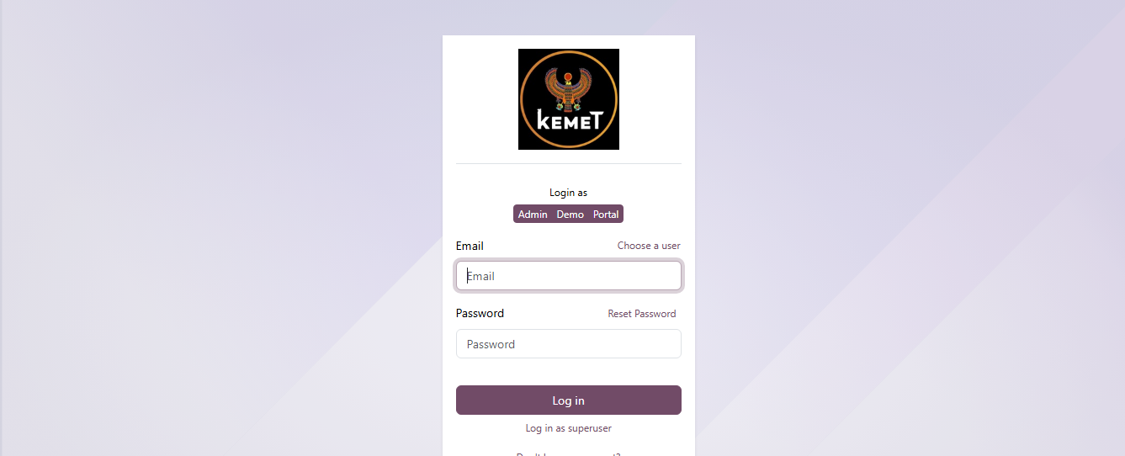

2-Purchase

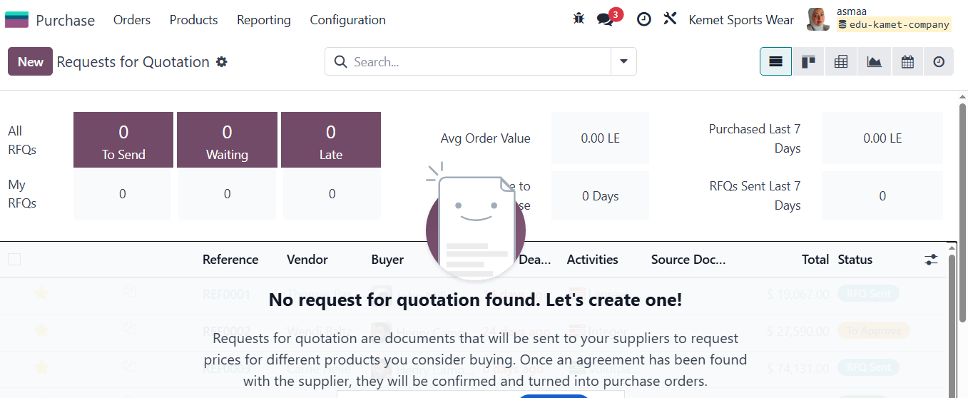

3-New RFQ/Vendor

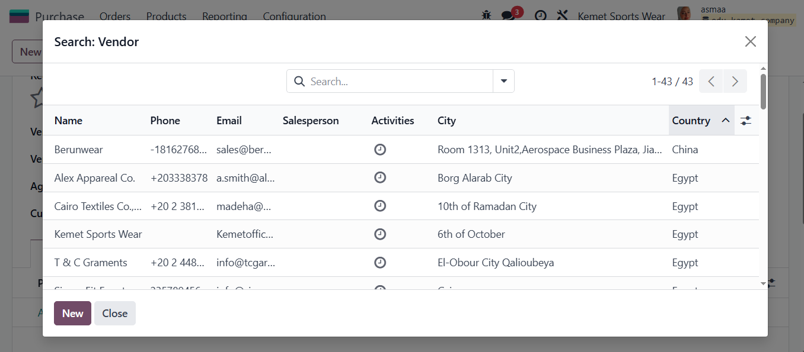

4-Select Vendor by Country to Import girl’s product

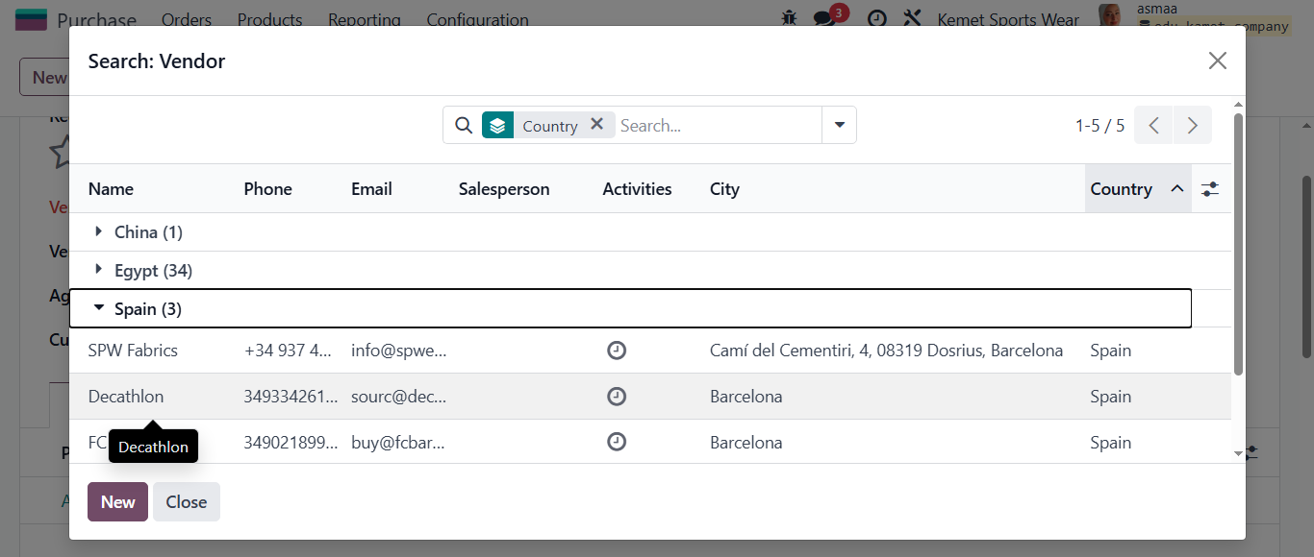

5-Expected arrived date

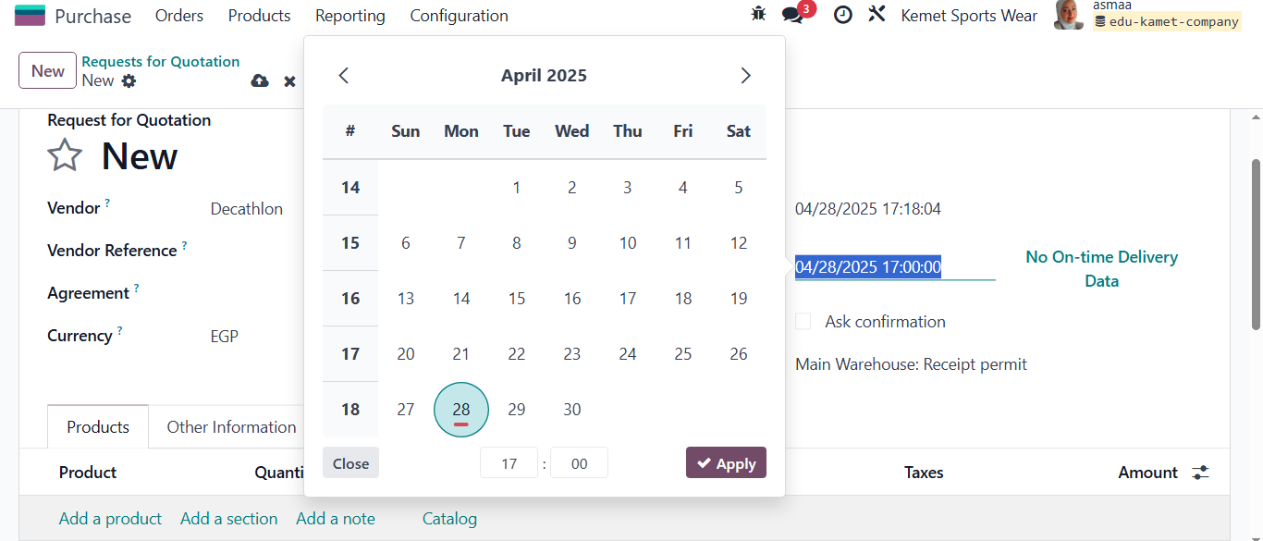

6- Selected Purchase Currency

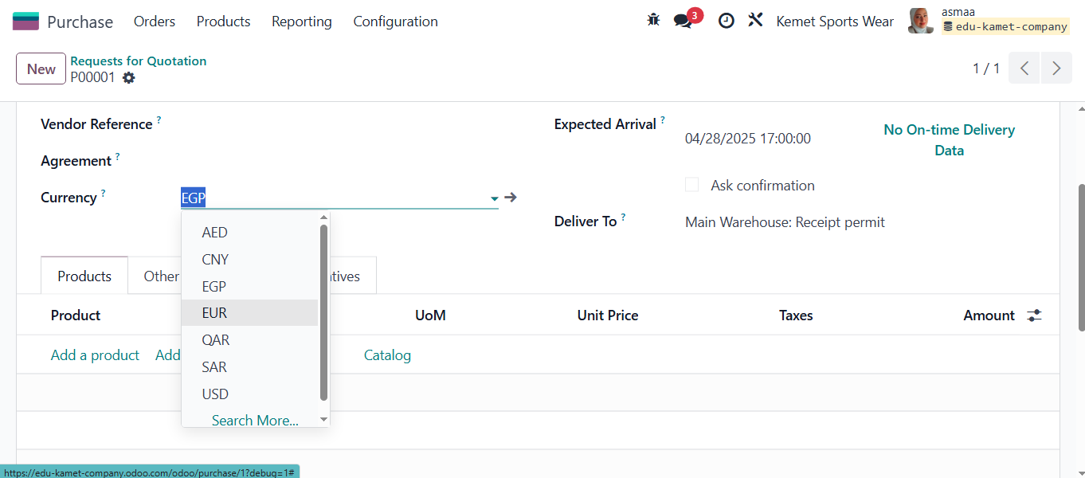

7-taken consideration to activate product variants grid

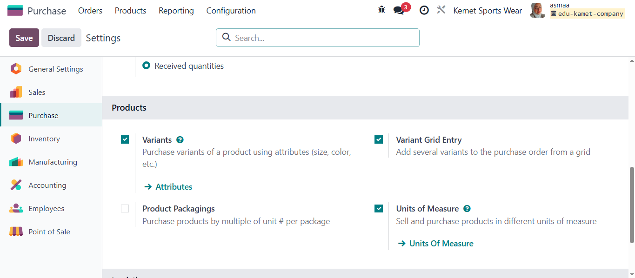

8- Product Variants grid quantity break down by size by color

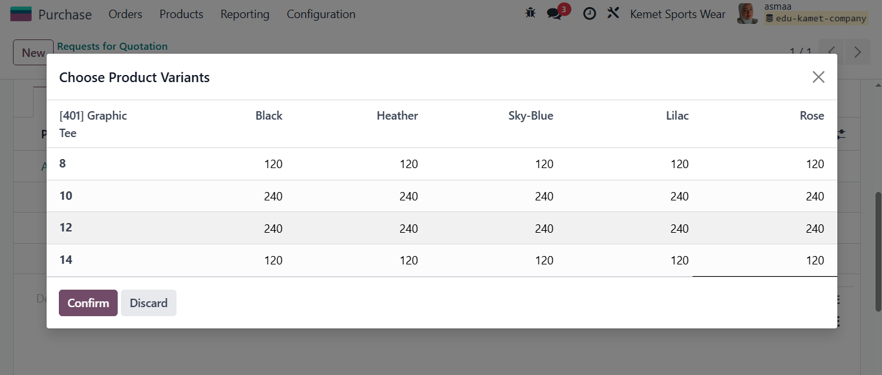

9- RFQ Products Girl 401

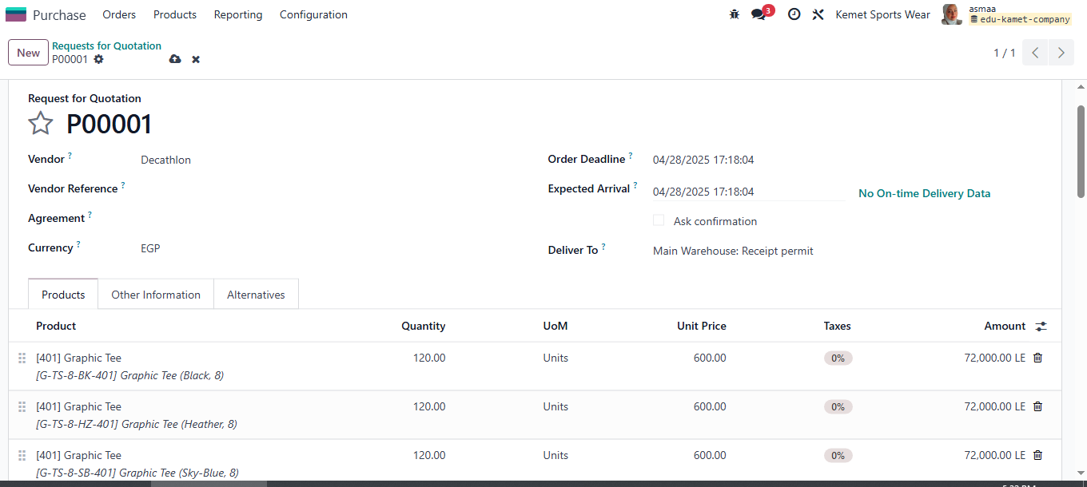

10- Indicate the power of multi currency of Odoo in RFQ( EUR-EGP)

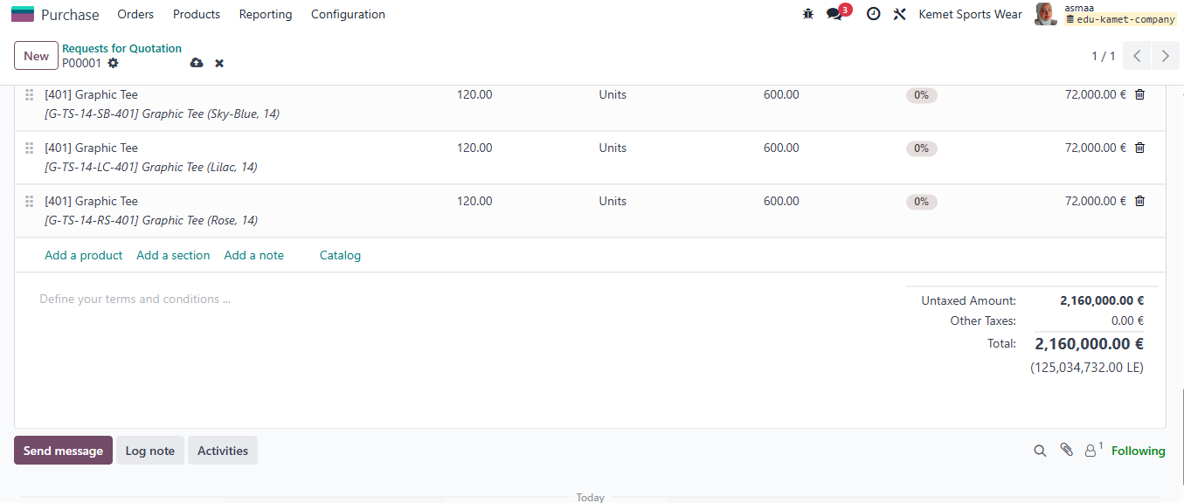

11-Select confirm RFQ

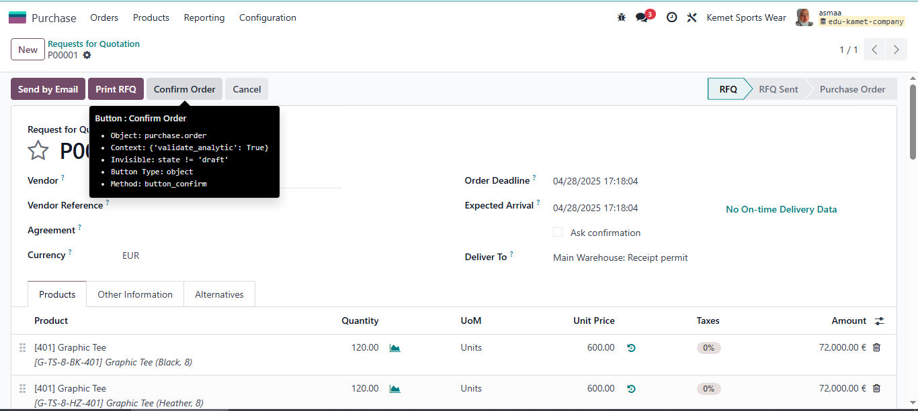

12-Receive Icon appear above PO indicate goods ready to receipt in warehouse

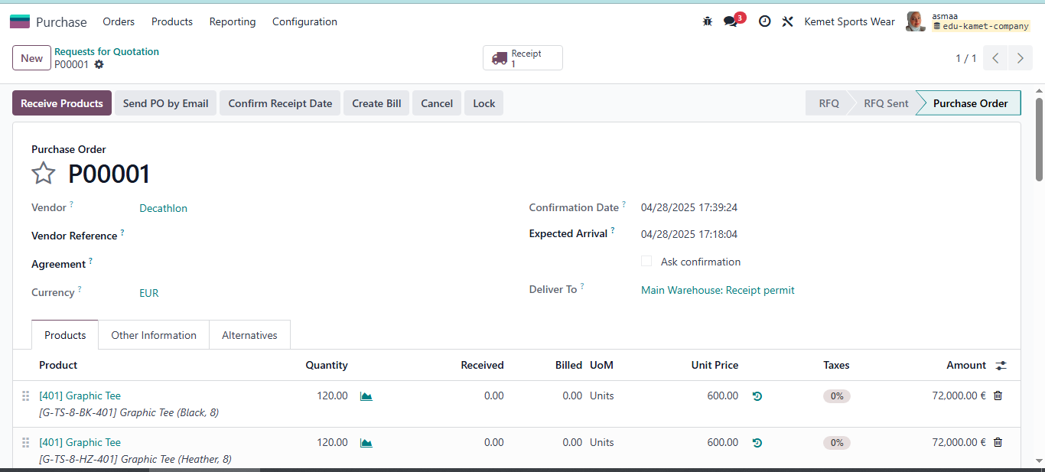

13- Go to inventory Module to receipt goods of PO0001

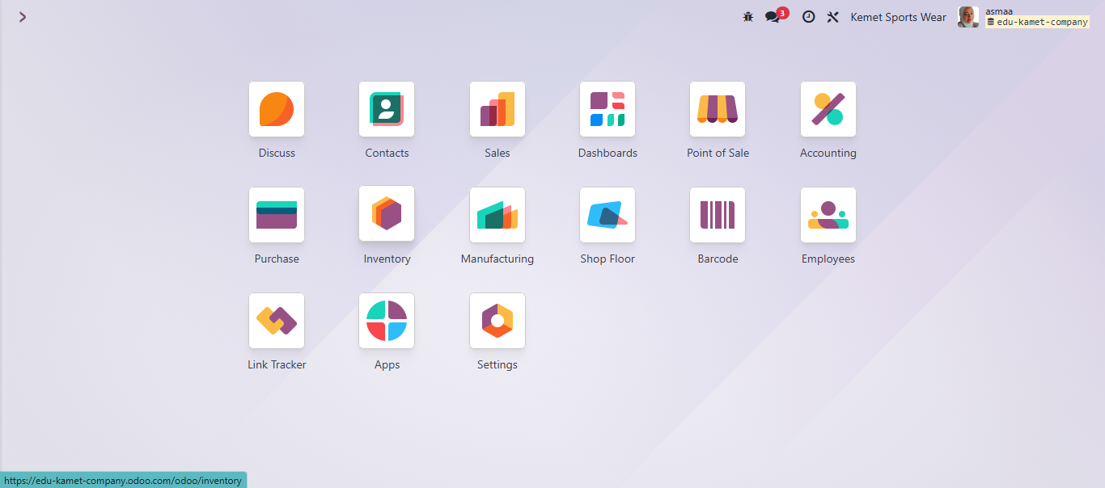

14- I n Inventory Module under receipt process there is one order to receive

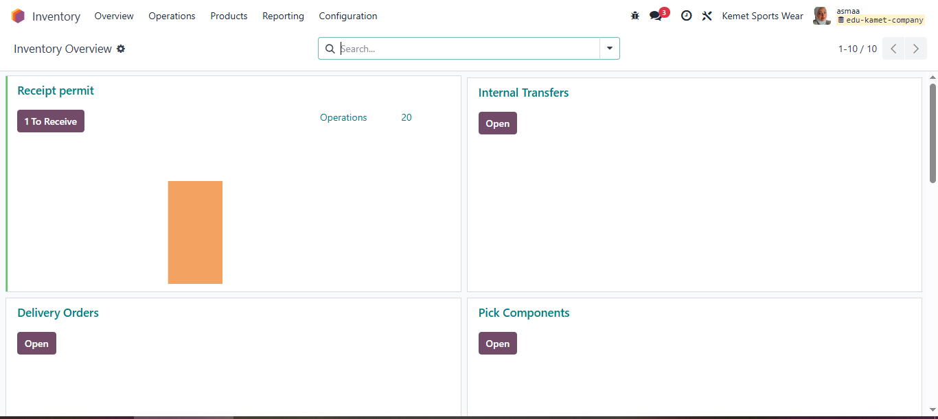

15-Inventory received -PO0001

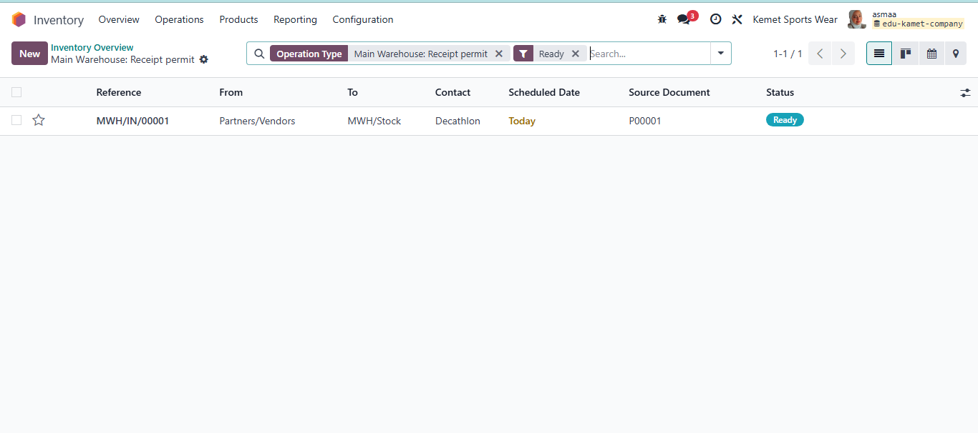

16- Validate received of PO0001 quantity

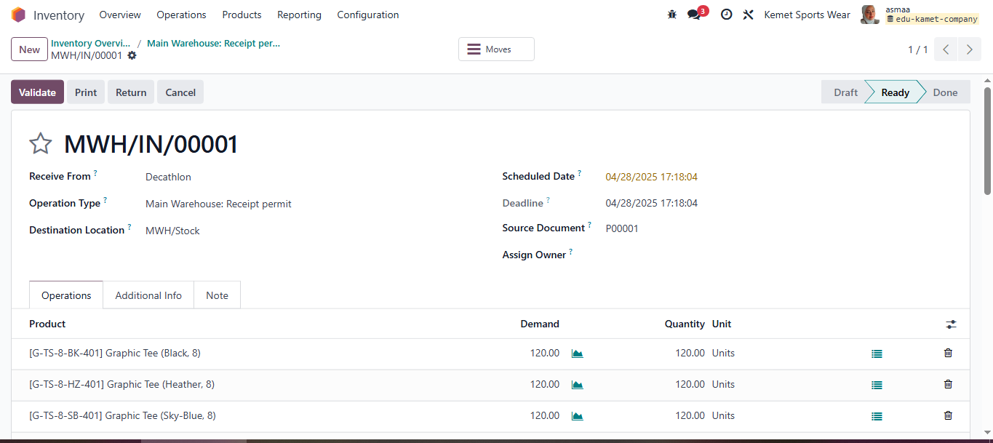

17-Make sure received quantity same as the demand quantity

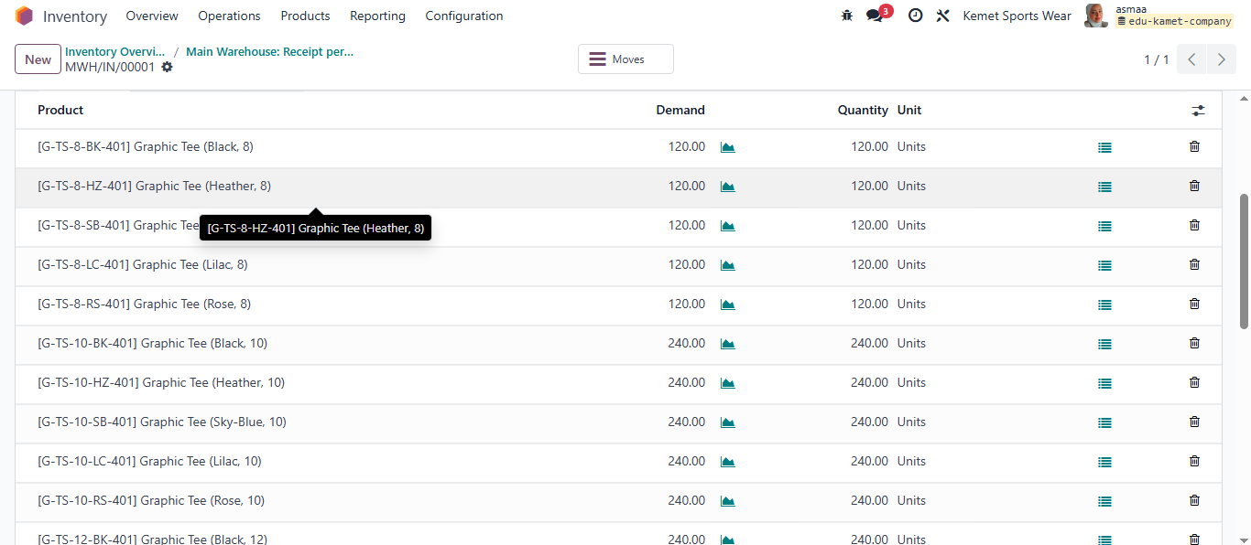

18-Warehouse Validated received full quantity of PO00001

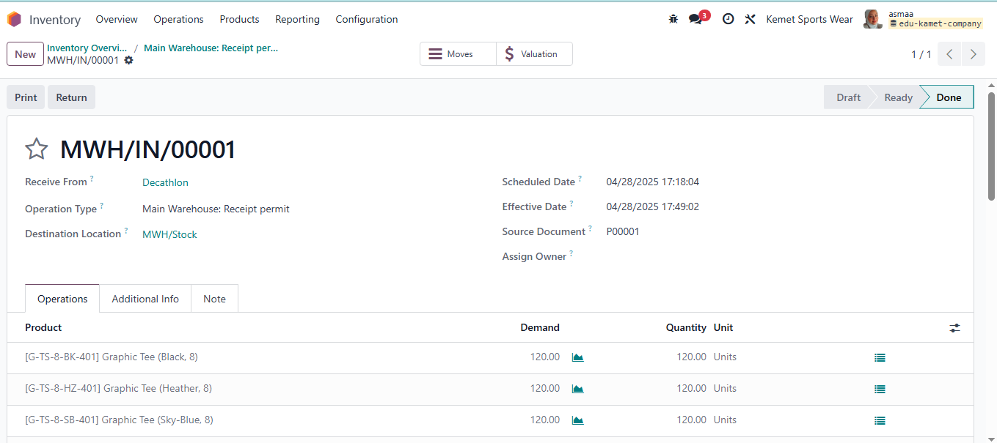

19-Check in Product girl 401 that quantity on hand is added successfully

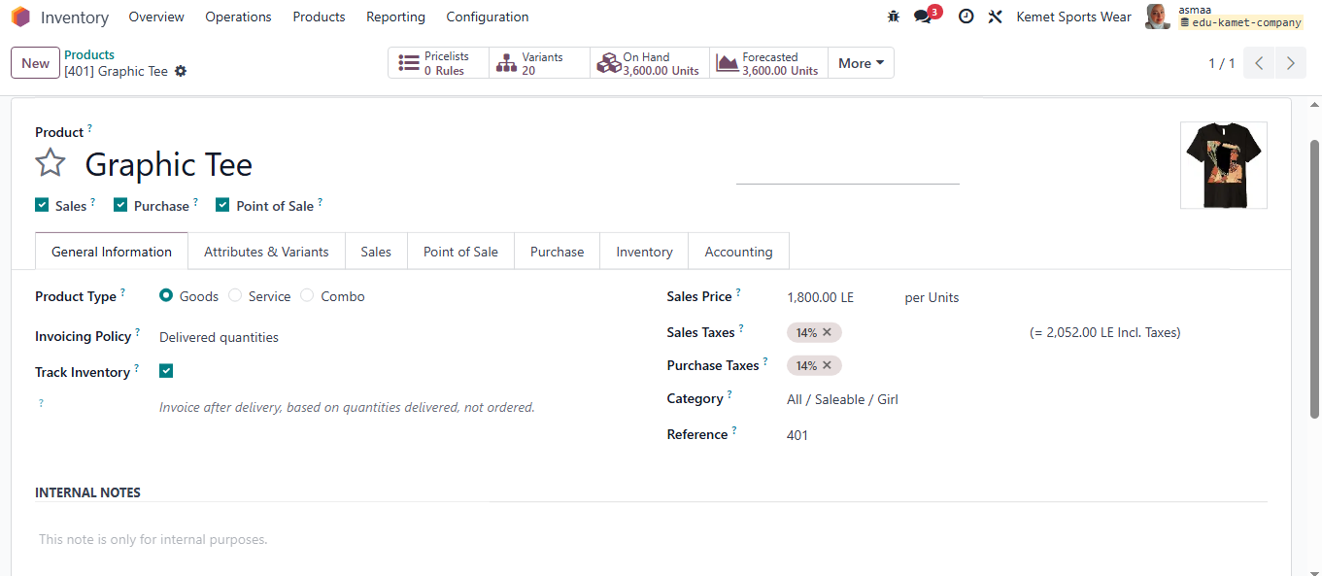

20-Quantity on hand of product girl 401 same as the RFQ/PO00001

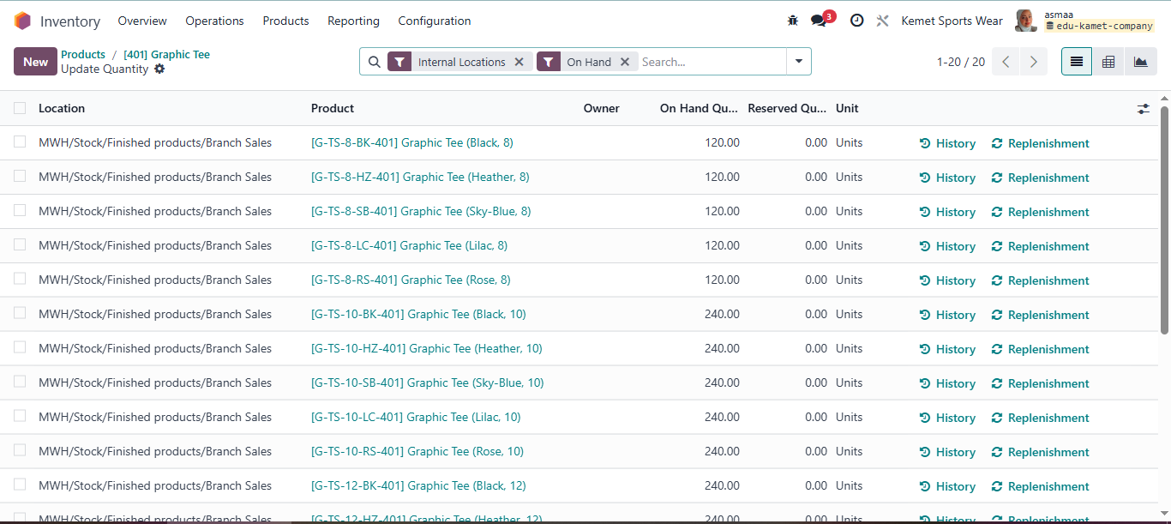

21-Returne to purchase module to create vendor bill

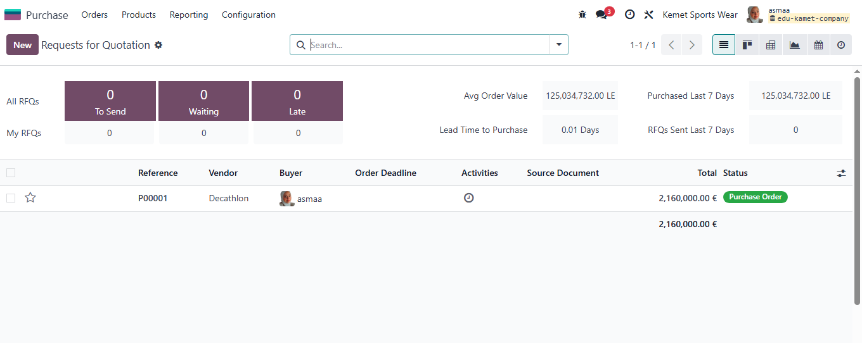

22-Create Vendor Bill for PO00001 as received full quantity in warehouse

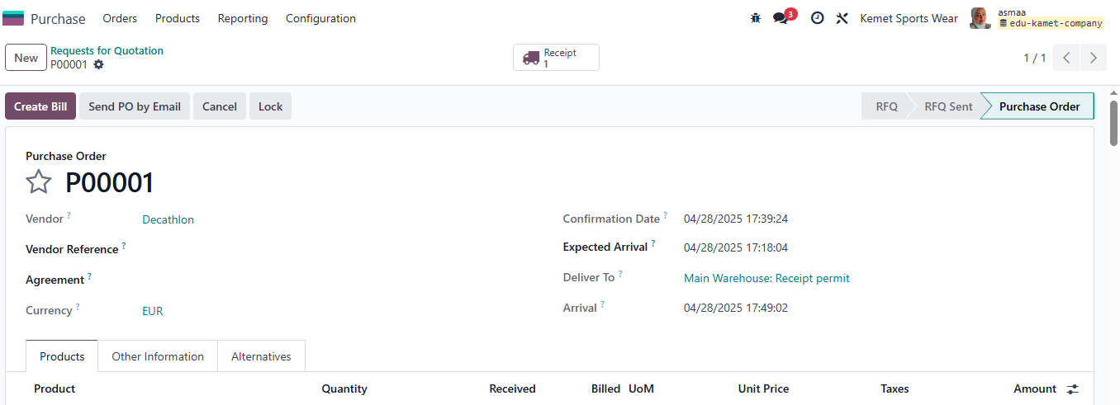

23- Vendor Bill to confirm

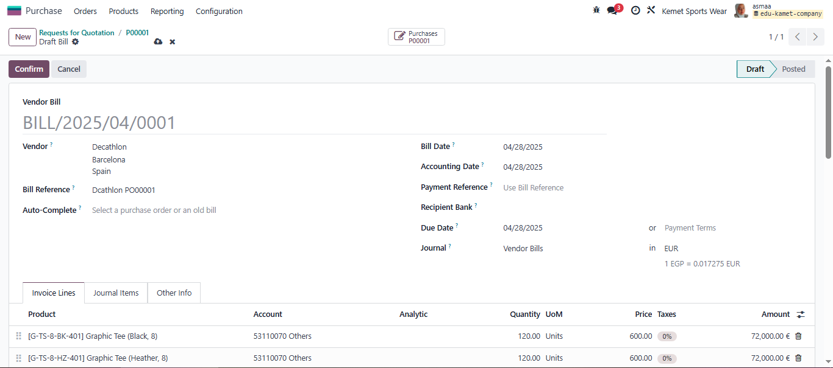

24-Vendor bill confirmed

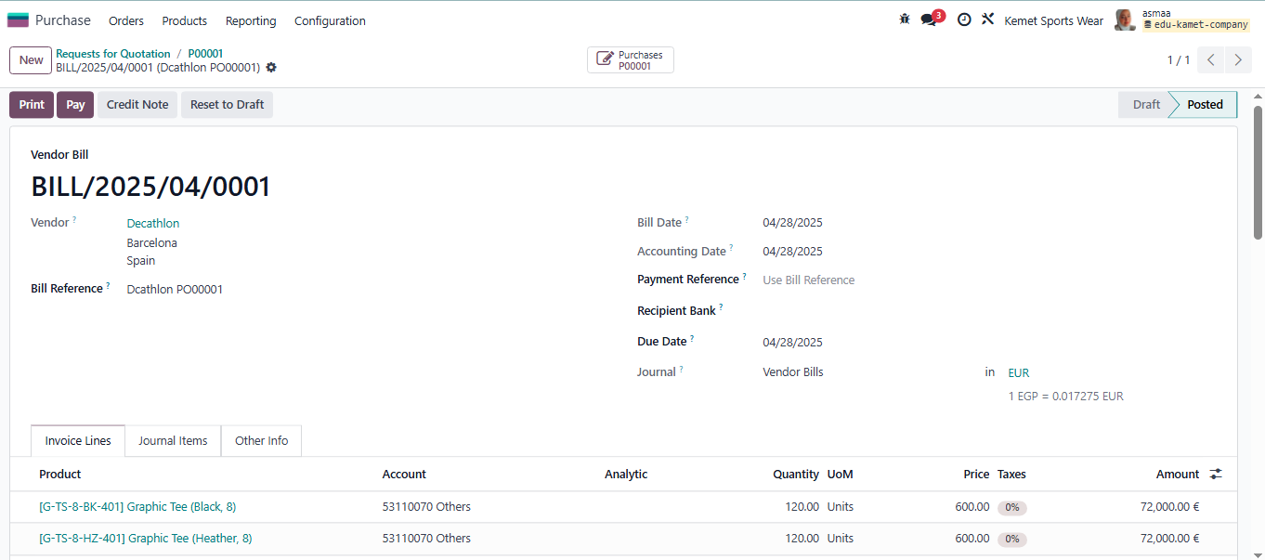

25-Moved to accounting Module to check journal entry automate created in both PO00001 and received inventory

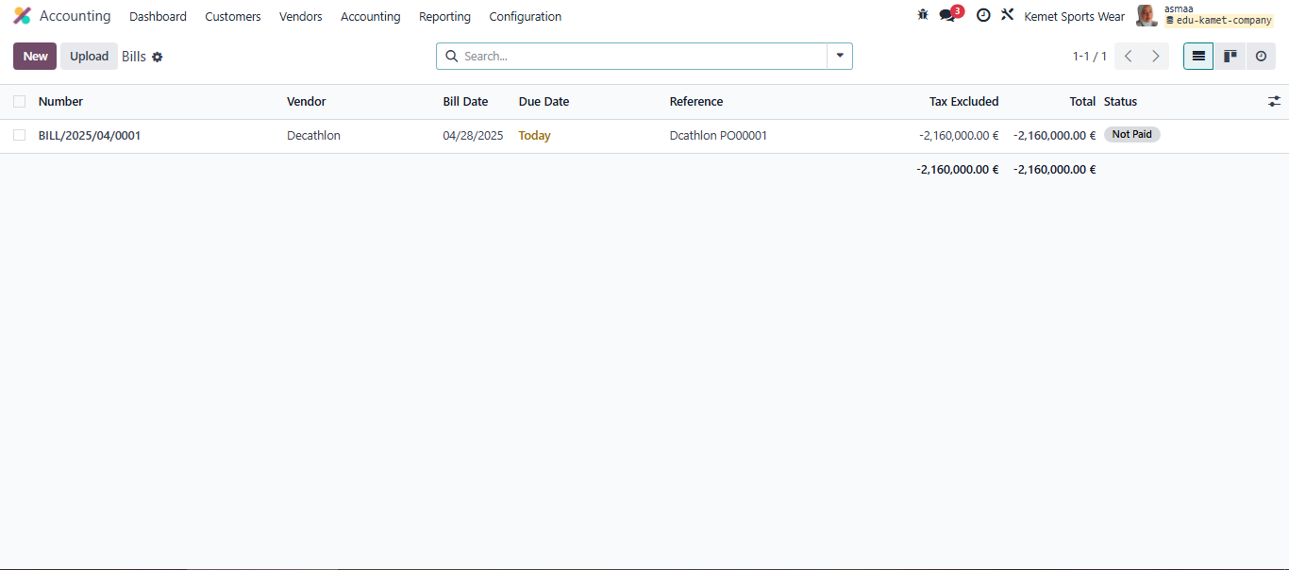

26-New RFQ for local purchase of Boy product from local vendor

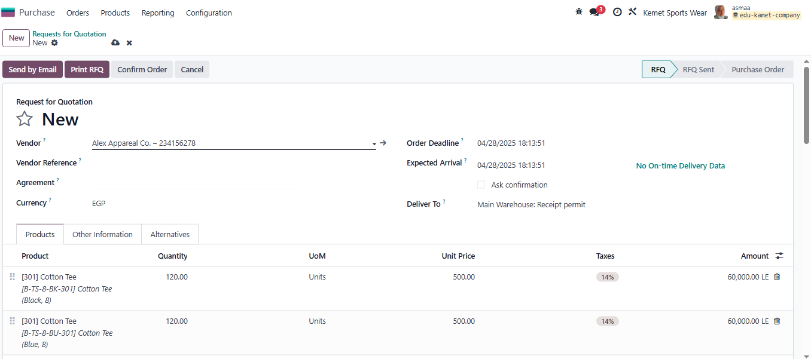

27-Total RFQ amount in EGP

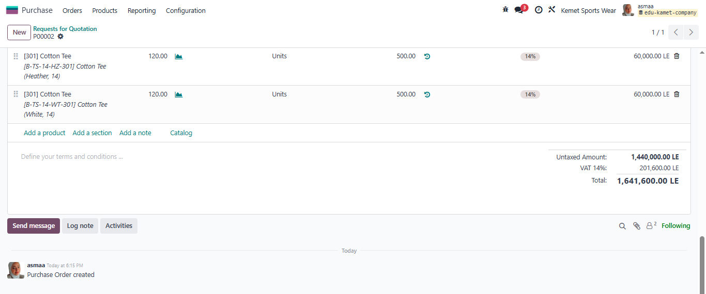

28-Warehouse location to indicate where local purchase stored PO0002

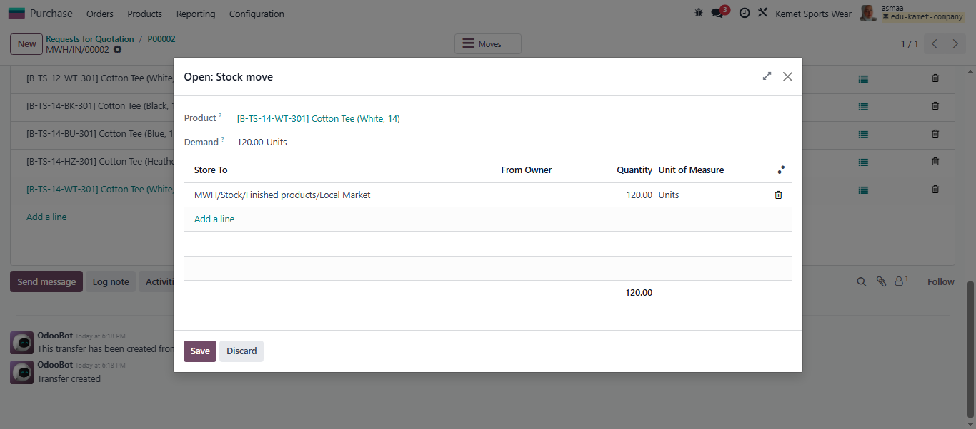

29-Check product quantity received in local warehouse for boy product 301 PO00002

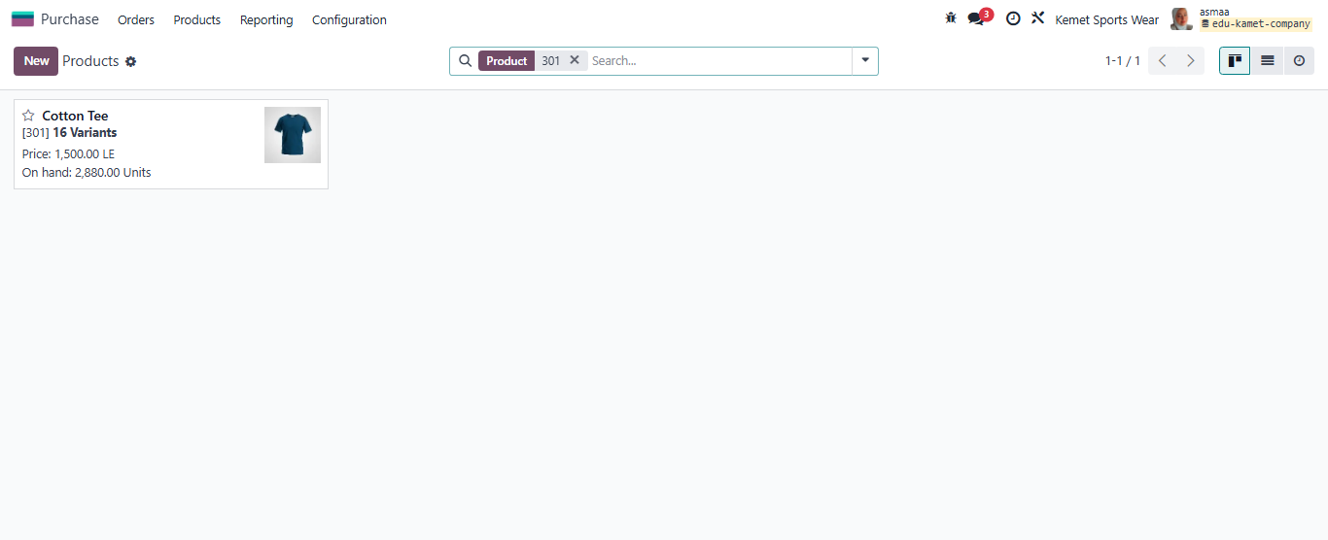

30-the quantity on hand for boy 301

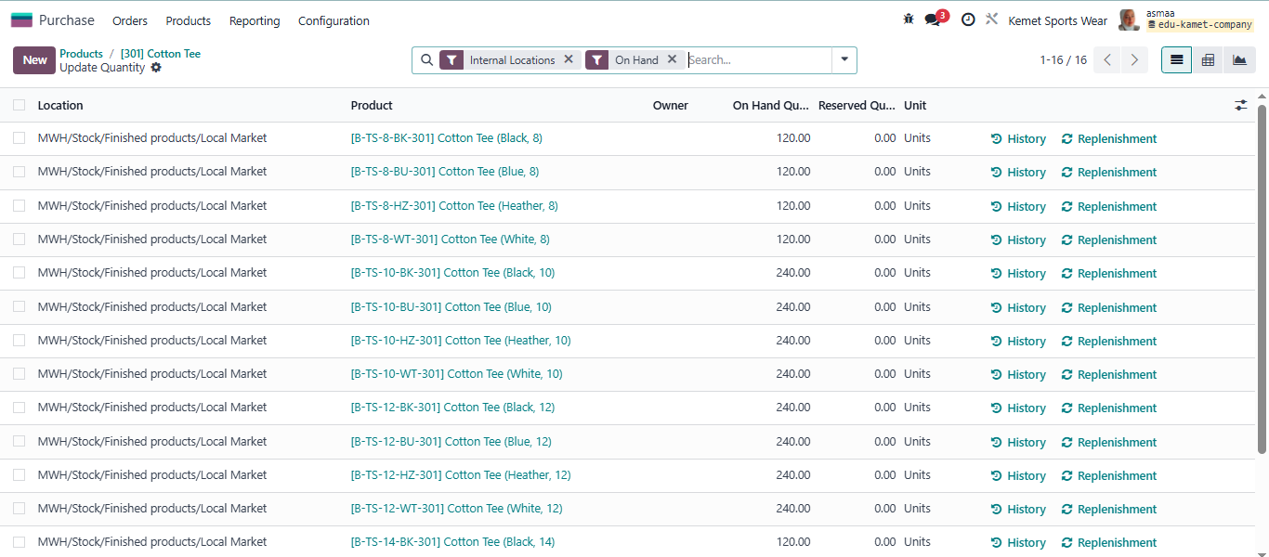

31-to create vendor bill we should add bill date and payment term

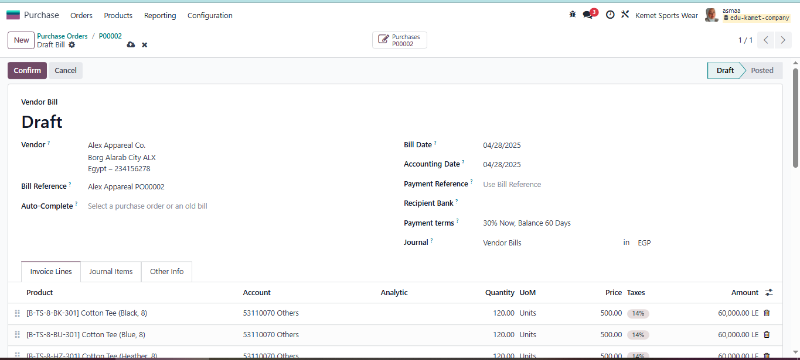

32-Vendor Bill confirmed

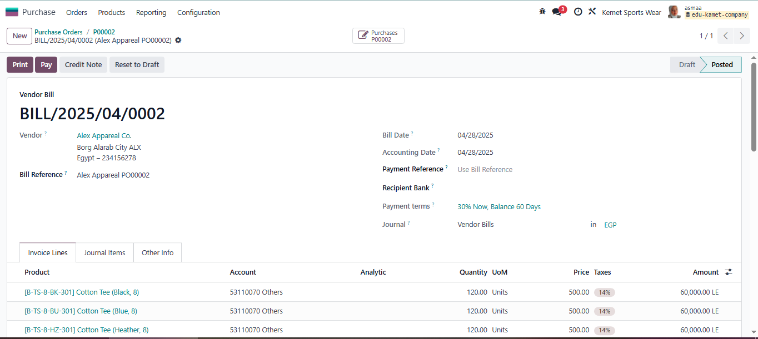

33-Accounting – vendor account indicated vendor confirmed bill

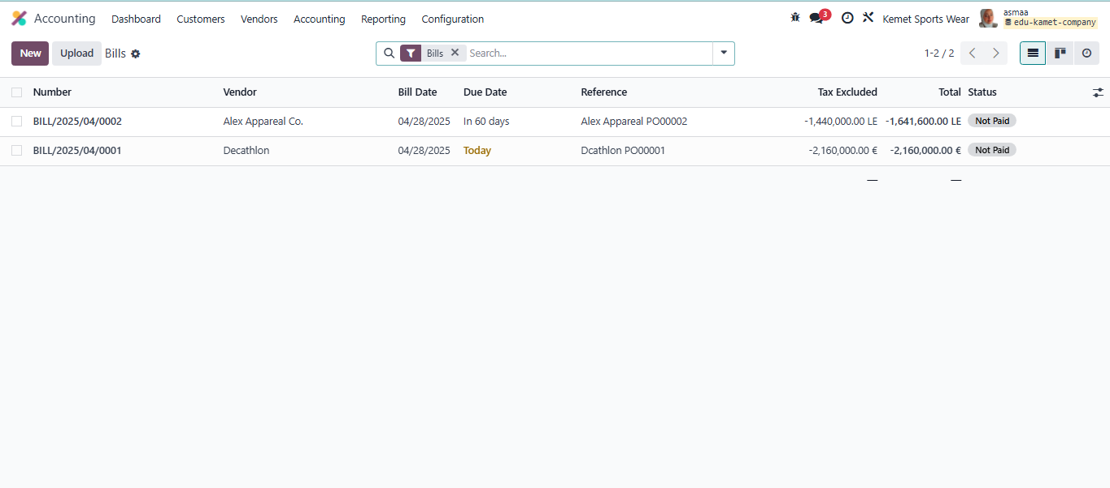

34-Journal Items of local vendor

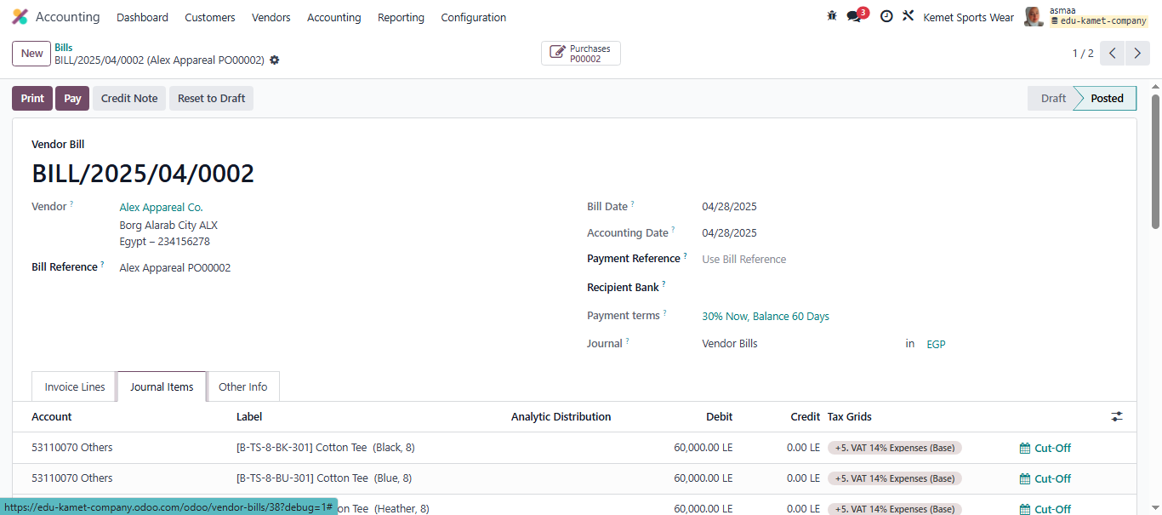

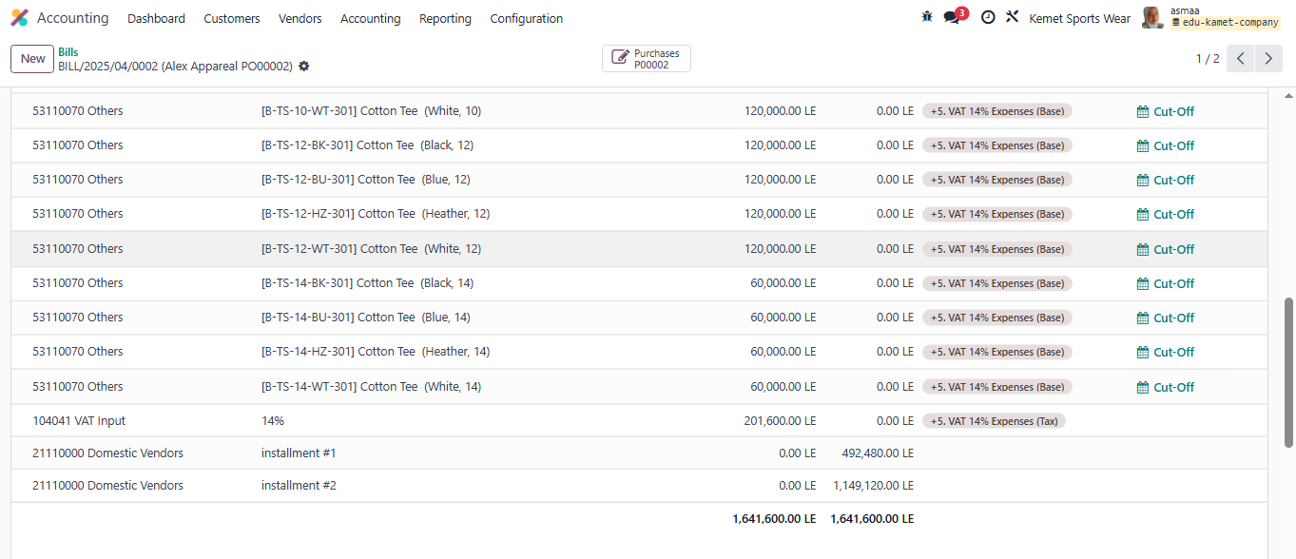

**Pro Sync integrated Solutions** **Kemet Sportswear Co.**

**Odoo ERR Consultant**  **Project Manager**

Ms. Asmaa Samir MR. Atef Ibrahim